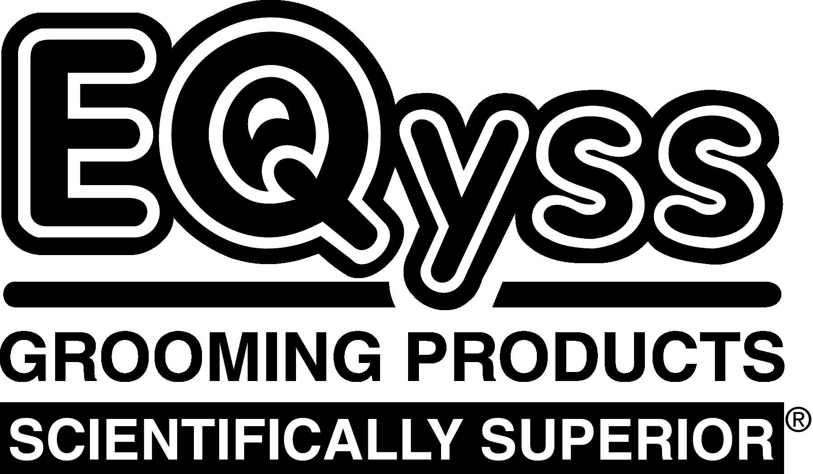 | EQyss Equine Grooming Products |  |  |  |  |  |  | SCAN BAR  CODE SHEET
PRODUCT |  |  | SIZE | UPC CODE |  | PRODUCT | SIZE |  | UPC CODE
Micro-Tek System Pack |  |  | 2 x 32 oz | 7 86232 10099 1 | 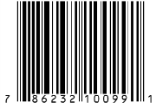 | Micro-Tek Spray | Gallon |  | 7 86232 10060 1 |  |  | 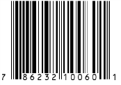
Premier System Pack |  |  | 2 x 32 oz | 7 86232 10090 8 | 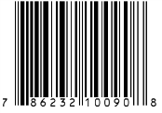 | Micro-Tek Spray | 32 oz |  | 7 86232 10050 2 |  |  | 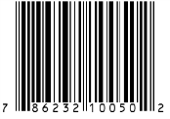
Avocado Mist Conditioner |  |  | Gallon | 7 86232 10260 5 | 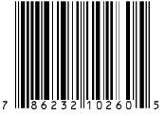 | Premier Conditioner | Gallon |  | 7 86232 10375 6 |  |  | 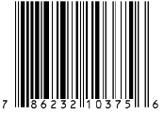
Avocado Mist Conditioner |  |  | 32 oz | 7 86232 10265 0 | 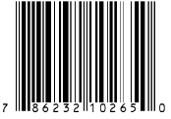 | Premier Conditioner | 16 oz |  | 7 86232 10380 0 |  |  | 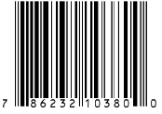
Canadian Marigold Spray |  |  | Gallon | 7 86232 10530 9 | 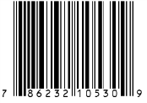 | Premier Shampoo | Gallon |  | 7 86232 10355 8 |  |  | 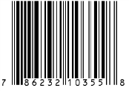
Canadian Marigold Spray |  |  | 32 oz | 7 86232 10535 4 | 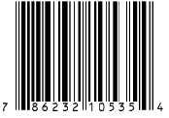 | Premier Shampoo | 32 oz |  | 7 86232 10350 3 |  |  | 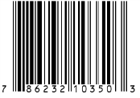
Mega-Tek Rebuilder |  |  | Gallon | 7 86232 10455 5 | 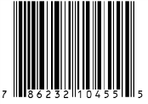 | Premier Spray | Gallon |  | 7 86232 10255 1 |  |  | 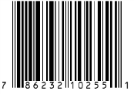
Mega-Tek Rebuilder |  |  | 16 oz | 7 86232 10445 6 | 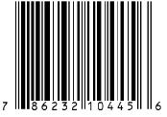 | Premier Spray | 32 oz |  | 7 86232 10250 6 |  |  | 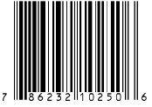
Micro-Tek Gel |  |  | 16 oz | 7 86232 10545 3 | 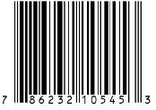 | Premier Spray  Marigold Scent | Gallon |  | 7 86232 10470 8 |  |  | 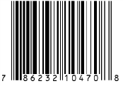
Micro-Tek Shampoo |  |  | Gallon | 7 86232 10155 4 | 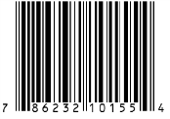 | Premier Spray  Marigold Scent | 32 oz |  | 7 86232 10475 3 |  |  | 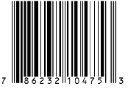
Micro-Tek Shampoo |  |  | 32 oz | 7 86232 10150 9 | 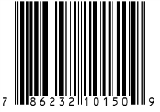 | Survivor Detangler  (new size) | 8 oz |  | 7 86232 10245 2 |  |  | 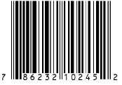
 |  | EQyss Grooming Products, Inc. • Box 130157 • Carlsbad CA 92013  800-526-7469 • www.EQyss.com |  |  |  |  |  |  |  | 102214

