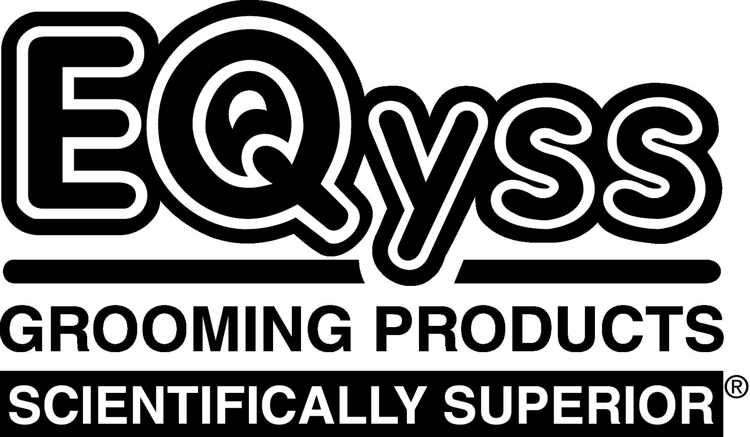 | EQyss Pet Grooming Products |  |  |  |  |  |  | SCAN BAR  CODE SHEET
PRODUCT |  |  | SIZE | UPC CODE |  | PRODUCT | SIZE |  | UPC CODE
Flea-Bite System Pack |  |  | 2 x 16 oz | 7 86232 12990 9 | 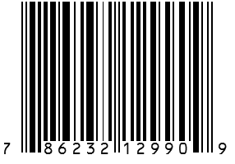 | Micro-Tek Shampoo | Gallon |  | 7 86232 10655 9 |  |  | 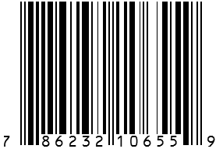
Micro-Tek System Pack |  |  | 2 x 16 oz | 7 86232 13990 8 | 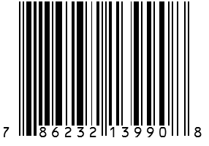 | Micro-Tek Shampoo | 16 oz |  | 7 86232 10640 5 |  |  | 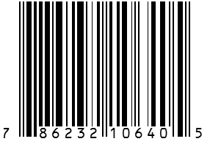
Premier System Pack |  |  | 2 x 16 oz | 7 86232 11990 0 | 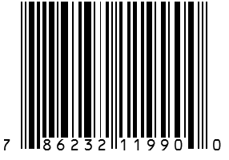 | Micro-Tek Spray | Gallon |  | 7 86232 10560 6 |  |  | 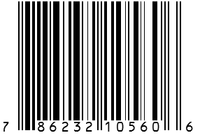
Avocado Mist Conditioner |  |  | Gallon | 7 86232 10870 6 | 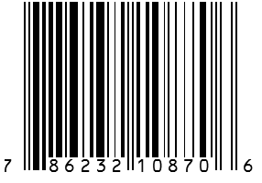 | Micro-Tek Spray | 16 oz |  | 7 86232 10540 8 |  |  | 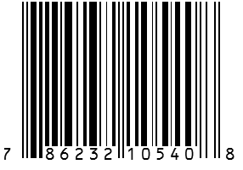
Avocado Mist Conditioner |  |  | 16 oz | 7 86232 10880 5 | 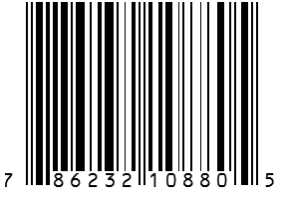 | Premier Conditioner | Gallon |  | 7 86232 10375 6 |  |  | 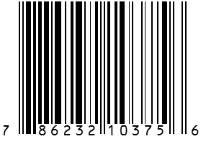
Canadian Marigold Spray |  |  | 16 oz | 7 86232 10525 5 | 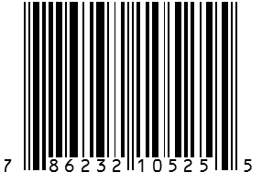 | Premier Conditioner | 16 oz |  | 7 86232 10895 9 |  |  | 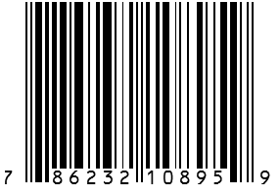
Flea-Bite Shampoo |  |  | Gallon | 7 86232 12055 5 | 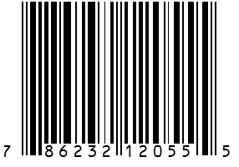 | Premier Shampoo | Gallon |  | 7 86232 10955 0 |  |  | 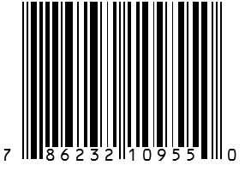
Flea-Bite Shampoo |  |  | 16 oz | 7 86232 12045 6 | 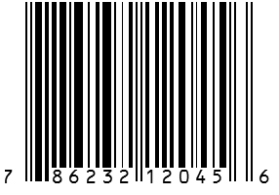 | Premier Shampoo | 16 oz |  | 7 86232 10945 1 |  |  | 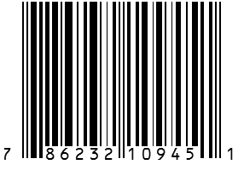
Flea-Bite Spray |  |  | 16 oz | 7 86232 12545 1 | 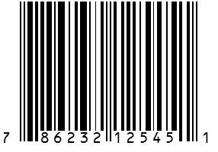 | Premier Spray | Gallon |  | 7 86232 10855 3 |  |  | 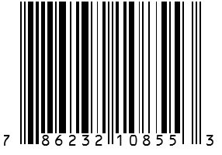
Mega-Tek Rebuilder  (new size) |  |  | 8 oz | 7 86232 10740 2 | 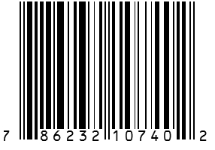 | Premier Spray | 16 oz |  | 7 86232 10845 4 |  |  | 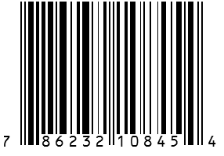
Mega-Tek Rebuilder |  |  | 2 oz | 7 86232 10720 4 | 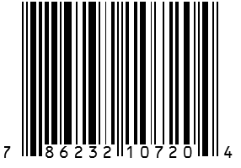 | Premier Spray Marigold Scent  (new size) | 4 oz |  | 7 86232 10295 7 |  |  | 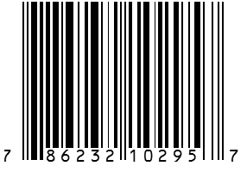
Micro-Tek Gel  (new size) |  |  | 4 oz | 7 86232 10435 7 | 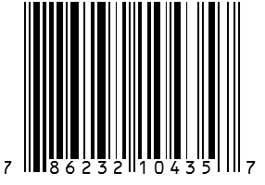 | Survivor Detangler | 4 oz |  | 7 86232 10756 3 |  |  | 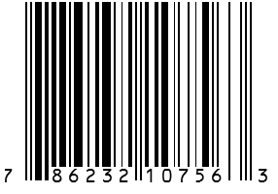
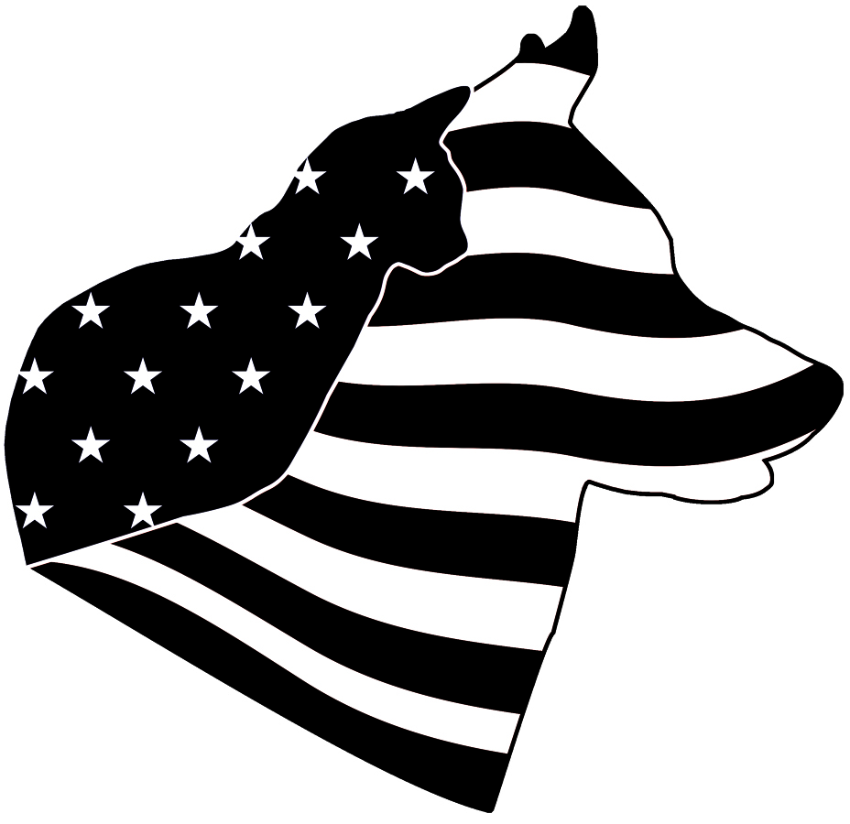 |  | EQyss Grooming Products, Inc. • Box 130157 • Carlsbad CA 92013  800-526-7469 • www.EQyssPet.com |  |  |  |  |  |  |  | 102214

